##### Questions:

1. Listthedepartmentswherethefacultymembers areworking.
2. Findthestudentwhohasnoscoreinanyofthecourses.Liststudentnameandcoursenumber.
3. Theofficeclerkneeds thenames ofthecourses takenbythefacultybelongingto‘ECEdepartment’whosenameis‘Kamal’

OUTPUTS:

1)

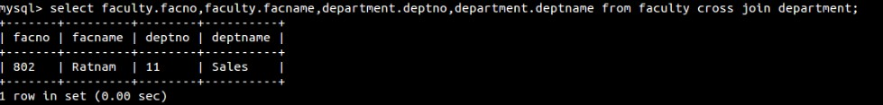

2)

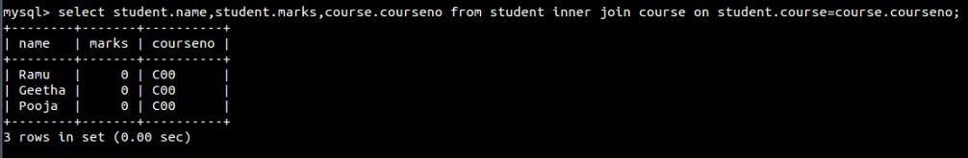

3)

